Research and design database schema for user token balances  
  
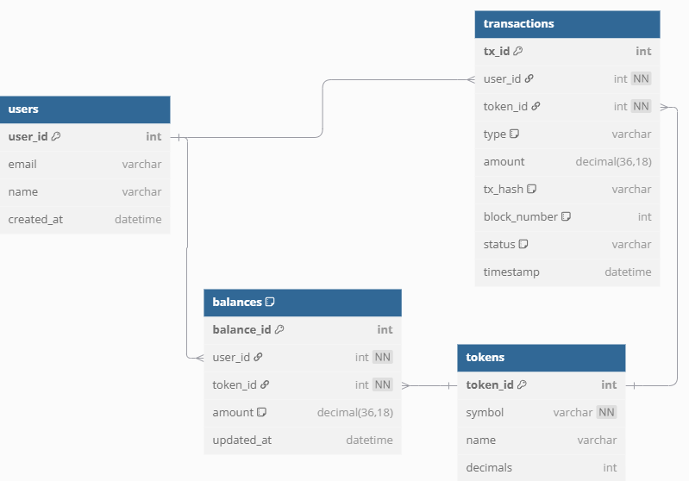

### **1. Users**

* user_id: Unique identifier
* email, name: Optional for internal or external account linking
* created_at: Useful for auditing

### **2. Tokens**

* token_id: Unique identifier for each token
* symbol: E.g., ETH, USDT, etc.
* name: Full name of token
* decimals: To convert on-chain values to human-readable format

### **3. Balances**

* Composite key on (user_id, token_id) ensures one row per token per user
* amount: Current off-chain balance
* updated_at: For auditing

### **4. Transactions**

* Tracks all token movements: deposits, withdrawals, internal transfers
* tx_id: Unique transaction identifier
* type: Enum: deposit, withdrawal, internal
* tx_hash: Real transaction hash (nullable for internal)
* block_number: Optional, for chain verification
* status: pending, confirmed, failed